Practical 4
Aim : Weather Analysis application using python and mapReduce
Step 1 : Creating a text file with all the weather data in a folder called weather
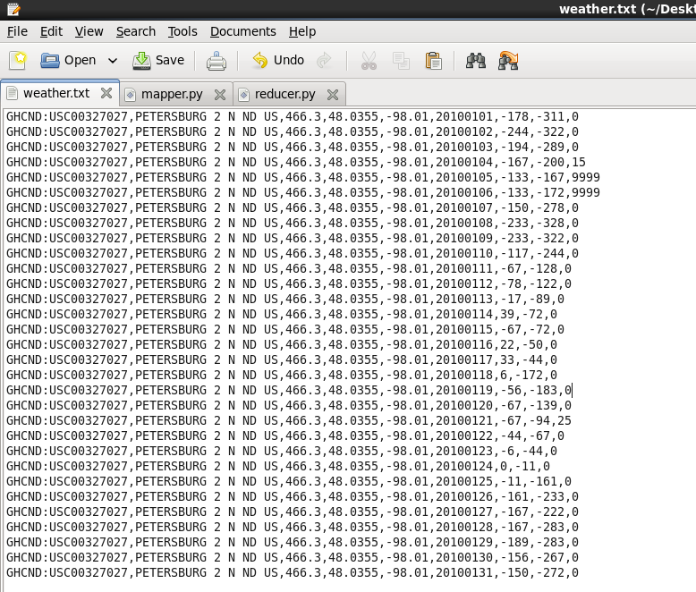

Step 2 : Create a mapper function in a python file called mapper.py.
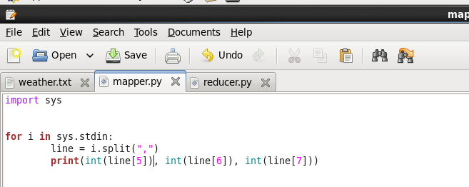

Step 3 : Creating a reducer function in the same folder weather
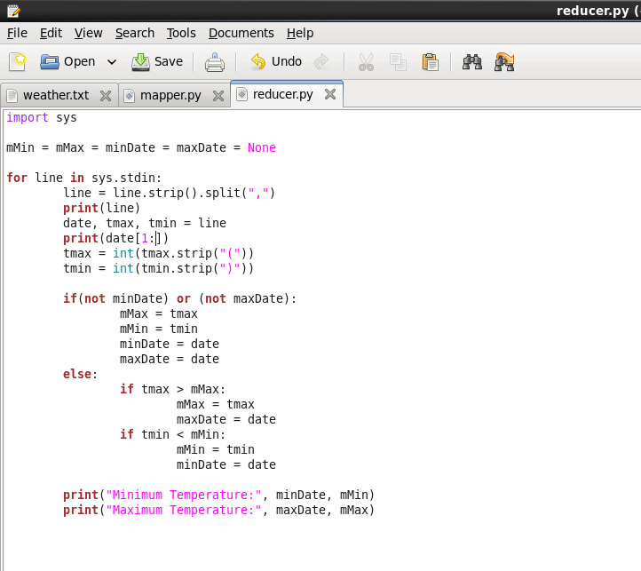

Step 4 : Running the mapper function with the weather text file to check the output
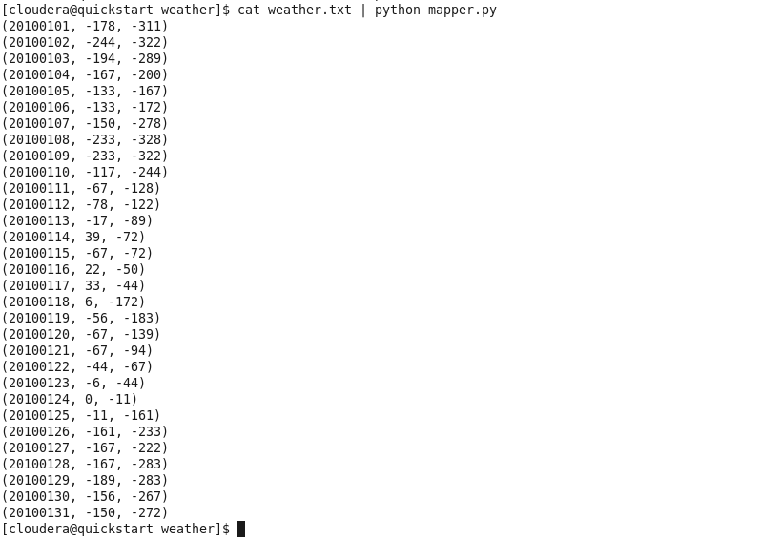

Step 5 : The mapper function will put these values in the stream which will be used by the reducer function and give the output
